**Name-Tasmiya Fathima**

**Usn-1BM19CS172**

**Program 7 -Book Database**

**BOOK (Book_id, Title, Publisher_Name, Pub_Year)**

**BOOK_AUTHORS (Book_id, Author_Name)**

**PUBLISHER (Name, Address, Phone)**

**BOOK_COPIES (Book_id, Branch_id, No-of_Copies)**

**BOOK_LENDING (Book_id, Branch_id, Card_No, Date_Out, Due_Date)**

**LIBRARY_BRANCH (Branch_id, Branch_Name, Address)**

create database Books;

use Books;

create table publisher (

name varchar (20) primary key,

phone integer,

address varchar (20)

);

desc publisher;

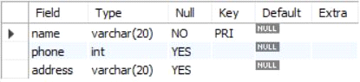

create table book (

book_id integer primary key,

title varchar (20),

pub_year varchar (20),

publisher_name varchar (20),

foreign key (publisher_name) references publisher (name) on delete cascade

);

desc book;

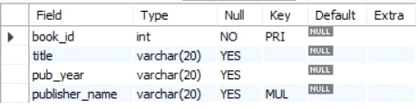

create table book_authors (

author_name varchar (20),

book_id integer,

foreign key (book_id) references book (book_id) on delete cascade,

primary key (book_id, author_name)

);

desc book_authors;

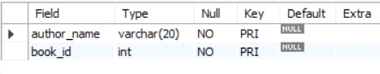

create table library_branch (

branch_id integer primary key,

branch_name varchar (50),

address varchar (50)

);

desc library_branch;

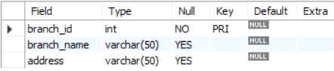

create table book_copies (

no_of_copies integer,

book_id integer,

branch_id integer,

foreign key (book_id) references book (book_id) on delete cascade,

foreign key (branch_id) references library_branch (branch_id) on delete cascade,

primary key (book_id, branch_id)

);

desc book_copies;

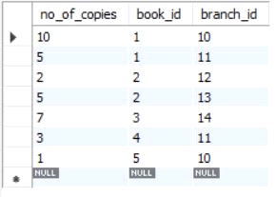

create table card (

card_no integer primary key

);

desc card;



create table book_lending (

date_out date,

due_date date,

book_id integer,

branch_id integer,

card_no integer,

foreign key (book_id) references book (book_id) on delete cascade,

foreign key (branch_id) references library_branch (branch_id) on delete cascade,

foreign key (card_no) references card (card_no) on delete cascade,

primary key (book_id, branch_id, card_no)

);

desc book_lending;

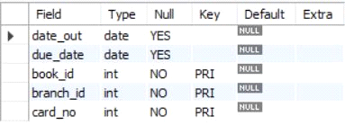

insert into publisher values ('mcgraw-hill', 99890, 'bangalore');

insert into publisher values ('pearson', 98890, 'newdelhi');

insert into publisher values ('random house', 74556, 'hyderabad');

insert into publisher values ('hachette livre', 897086, 'chenai');

insert into publisher values ('grupo planeta', 77561, 'bangalore');

select * from publisher;

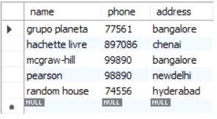

insert into book values (1,'dbms','01-2017', 'mcgraw-hill');

insert into book values (2,'adbms','06-2016', 'mcgraw-hill');

insert into book values (3,'cn','09-2016', 'pearson');

insert into book values (4,'cg','09-2015', 'grupo planeta');

insert into book values (5,'os','05-2016', 'pearson');

select * from book;

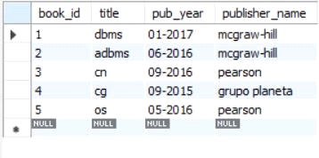

insert into book_authors values ('navathe', 1);

insert into book_authors values ('navathe', 2);

insert into book_authors values ('tanenbaum', 3);

insert into book_authors values ('edward angel', 4);

insert into book_authors values ('galvin', 5);

select * from book_authors;

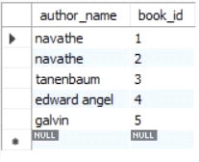

insert into library_branch values (10,'rr nagar','bangalore');

insert into library_branch values (11,'rnsit','bangalore');

insert into library_branch values (12,'rajaji nagar', 'bangalore');

insert into library_branch values (13,'nitte','mangalore');

insert into library_branch values (14,'manipal','udupi');

select * from library_branch;

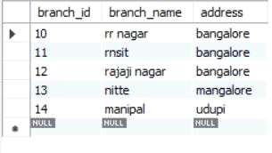

insert into book_copies values (10, 1, 10);

insert into book_copies values (5, 1, 11);

insert into book_copies values (2, 2, 12);

insert into book_copies values (5, 2, 13);

insert into book_copies values (7, 3, 14);

insert into book_copies values (1, 5, 10);

insert into book_copies values (3, 4, 11);

select * from book_copies;

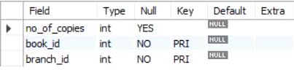

insert into card values (100);

insert into card values (101);

insert into card values (102);

insert into card values (103);

insert into card values (104);

select * from card;

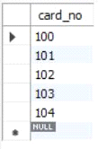

insert into book_lending values ('01-01-17','01-06-17', 1, 10, 101);

insert into book_lending values ('11-01-17','11-03-17', 3, 14, 101);

insert into book_lending values ('21-02-17','21-04-17', 2, 13, 101);

insert into book_lending values ('15-03-17','15-07-17', 4, 11, 101);

insert into book_lending values ('12-08-17','12-08-17', 1, 11, 104);

select * from book_lending;

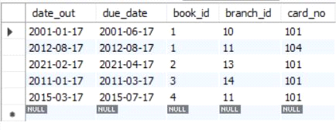

Write SQL queries to

**1.Retrieve details of all books in the library – id, title, name of publisher, authors, number of copies in each branch, etc.**

select b.book_id, b.title, b.pub_year, b.publisher_name, bc.no_of_copies, ba.author_name, lb.branch_name from book b, book_authors ba,

library_branch lb, book_copies bc where b.book_id = ba.book_id and b.book_id = bc.book_id and lb.branch_id = bc.branch_id;

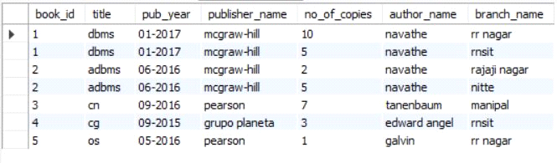

**2.Get the particulars of borrowers who have borrowed more than 3 books, but from Jan 2017 to Jun 2017**

select card_no from book_lending where year(date_out) >17 and month(date_out)<7 group by card_no having count(card_no) >2 ;



**3.Delete a book in BOOK table. Update the contents of other tables to reflect this data manipulation operation.**

delete from book where book_id = 3;

select * from book;

select * from book_authors;

select * from book_copies;

select * from book_lending;

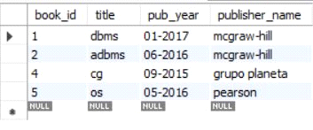

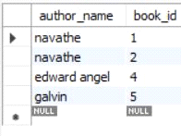

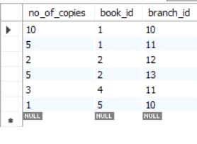

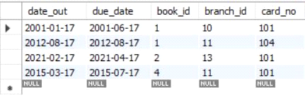

**4.Partition the BOOK table based on year of publication. Demonstrate its working with a simple query.**

create view partition select pub_year from book;

select * from partition;

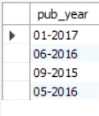

**5.Create a view of all books and its number of copies that are currently available in the Library**.

create view book_copies as select b.book_id, b.title, bc.no_of_copies from book b,

book_copies bc where b.book_id = bc.book_id;

select * from book_copies;

